Name ________________________________ Similar Triangles WS #1

The following sets of triangles are NOT drawn to scale. Determine if the triangles are similar.
EXPLAIN WHICH THEOREM ALLOWED YOU TO MAKE YOUR CONCLUSION.
Use your awesome flow chart!!

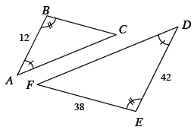
1.

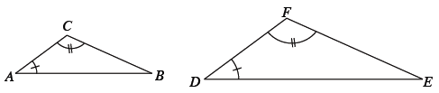
2.

3.

4.

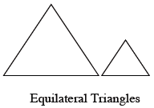
5.

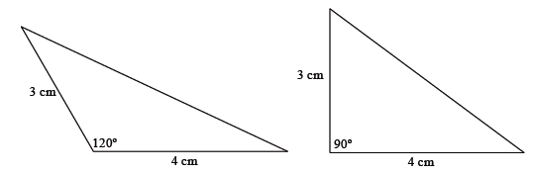
6.

7. OUTLINE the two triangles in different colors.
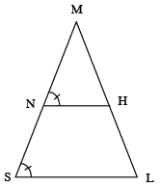

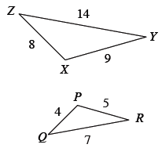
8.

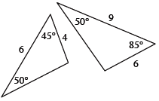
9.

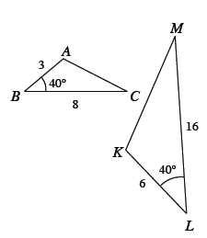

10.

