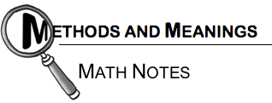
Name: _________________________________
Date: __________________________
Class: __________________________

Chapter 2 – Graphing accurate lines using multiple methods.
- Provide a COMPLETE and DETAILED explanation about how to graph a line given the following components.
- Make sure you include an example (sketch).
- Worth 20 points.
How do you graph a line GIVEN a slope?
How do you graph a line GIVEN 2 points?
How do you graph a line GIVEN slope and a point?
How do you graph a line GIVEN equation?
In the situations above, when do you have enough information to graph ONE EXACT line?
When is it not enough information to graph the EXACT line (what more did you need)?
What do you ALWAYS need to graph an EXACT line?
How do you graph a line GIVEN a point?
How do you graph a line GIVEN a x/y table?

