Name ________________________________ HW # 18 - Appendix
Class _______________ Combining Like Terms

Simplify by categorizing with shapes, colors, symbols. SHOW ALL YOUR WORK

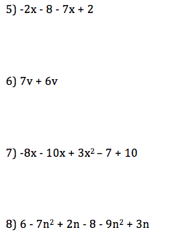
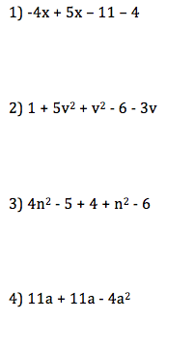

Name ________________________________ HW # 18 - Appendix
Class _______________ Combining Like Terms

Simplify by categorizing with shapes, colors, symbols. SHOW ALL YOUR WORK

1) x  x –  – 

2)   v²  v²   - 3v

3) n²  5    n²  

4) a  a - 4a²

5) x    x  

6) v  v

7) x  x + 3x² – 7 + 10

8)   n² + n   - n²  n

