Name _________________________________________ Exit Slip #2 – Graphing
Line A
y-intercept __________________
slope _________________________
Equation _____________________
Is the coordinate (5,9) on this line?
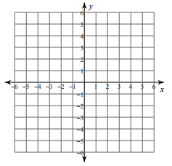

Line B
y-intercept = -3
slope = $-\frac{3}{2}$
Equation _____________________
Is the coordinate (-4,4) on this line?

Name _________________________________________ HW #16
Line A
y-intercept __________________
slope _________________________
Equation _____________________
Is the coordinate (5,9) on this line?

Line B
y-intercept = -3
slope = $-\frac{3}{2}$
Equation _____________________
Is the coordinate (-4,4) on this line?

3. Find the value of y given that x = -4 and x = 8.
$y=-\frac{5}{4}x-3$

4. Find the value of y given that x = -6 and x = 10.

$y=-\frac{1}{2}x+7$

3. Find the value of y given that x = -4 and x = 8.
$y=-\frac{5}{4}x-3$

4. Find the value of y given that x = -6 and x = 10.

$y=-\frac{1}{2}x+7$

