Name ____________________________________ Multiplying Like Bunnies

In the book Of Mice and Men by John Steinbeck, two good friends named Lenny and George dream of getting rich by raising and selling rabbits. Suppose Lenny and George started with only two rabbits; after a month the two rabbits will have two babies. Assume that every month thereafter, each pair of rabbits will have two babies (one male and one female).

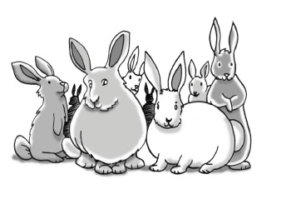
Your Task: With your team, determine how many rabbits Lenny and George would have after one year (12 months).

You are responsible for representing your data (the pattern of growth) by using a diagram, a table, a graph, and a written description. What patterns can you find and how do they compare to other patterns that you have investigated previously?

- Underline the question you and your team are trying to answer.

- Briefly explain what you and your team will need to do to find an appropriate solution to this problem.
_______________________________________________________________________________________________________________________________________________________________________________________________________________________________________________________________________________________________________________________________________________________________

Getting started …

- How many rabbits do L&G have MONTH 0? ______________________________________

- How many babies are born after MONTH 0? ______________________________________

- How many total rabbits do L&G have MONTH 1? _________________________________

- How many total rabbits do L&G have MONTH 2? _________________________________

Task 2 - Table

- Collect the appropriate data to fill into the chart below. Use the empty space below to show your calculations.

- Label the table with the appropriate headings.
    - What does the left column represent? ___________________________________________
    - What does the right column represent? ___________________________________________

0
1
2
3
4
5
6

★  Describe how you notice the pattern is growing. Use specific descriptive words (increasing, decreasing, steady, positive, negative, fast, slow, slope, etc.). Try to explain why this happens. ____________________________________________________________________________________________________________________________________________________________________________________________________________________________________________________________________________________________________________________________________________________________________________________________________________________________________________________________________________________________________________________________________________________________________________________________________________________________________________________

Task 1 – Diagram

Draw a diagram (picture, visual representation, graphical story) to represent how the total number of rabbits is growing each month. Accuracy is important!! (Hint: Use symbols to represent bunnies)

- How many rabbits will L&G have after 3 MONTHS? _________________________________

- Explain what are some of the limitations (ie: boundaries, restrictions, difficulties) to using a diagram to figure out how many rabbits L & G have after 6 months?

___________________________________________________________________________________________________________________________________________________________________________________________________________________________________________________________________________________________________________________________________________________________________________
__________________________________________________________________________________________________________________________________________________________________________________________________________________________________________________

Task 3 – More Options!

Lenny and George want to raise as many rabbits as possible, so they have a few options to consider. They could start with a larger number of rabbits, or they could raise a breed of rabbits that reproduces faster.

Your Task To help answer these questions, model each case below with a table for the first six months.
Case A: Start with 10 rabbits; each pair has 2 babies per month.
Case B: Start with 2 rabbits; each pair has 4 babies per month.
Case C: Start with 2 rabbits; each pair has 6 babies per month.
After calculating the appropriate data and research decide which case would appear to give L&G the most rabbits after one year?

Case A Start with 10 rabbits; each pair has 2 babies per month.

Case B Start with 2 rabbits; each pair has 4 babies per month.
- Label the table with appropriate headings.
- Insert the appropriate data and results.
- Describe how the pattern is growing. (increasing HOW?) ____________________________________________________________________________________________________________________________________________________________________________________________________________________________________________________________________
- Label the table with appropriate headings.
- Insert the appropriate data and results.
- Describe how the pattern is growing. (increasing HOW?) ____________________________________________________________________________________________________________________________________________________________________________________________________________________________________________________________________

Case C Start with 2 rabbits; each pair has 6 babies per month.
- Label the table with appropriate headings.
- Insert the appropriate data and results.
- Describe how the pattern is growing. (increasing HOW?) ____________________________________________________________________________________________________________________________________________________________________________________________________________________________________________________________________

Which case would provide L&G the most rabbits after 1 year? Provide a reason/rationale.

________________________________________________________________________________________________________________________________________________________________________________________________________________________________________________________________________________________________________________________________________________________________________________________________________________________________________________________________________________________
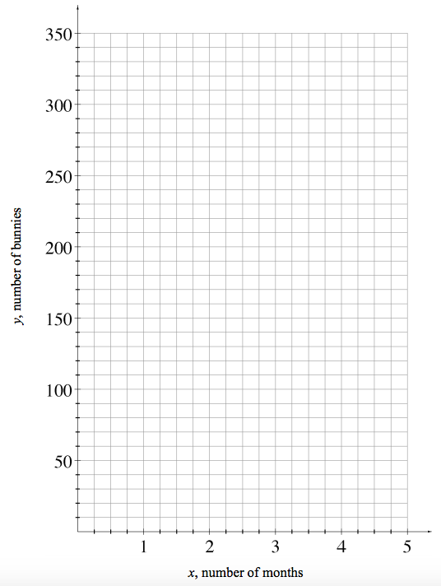
Graph Case A, B, and C on the following chart.

Describe the 3 different graphs ______________________________________________________________________________________________________________________________________________________________________________________________________________________________________________________________________________________________________________________________________________________

